Array Lists and Arrays

Chapter Goals
- To become familiar with using array lists to collect objects
- To learn about common array algorithms
- To be able to use arrays
- To understand when to choose array lists and arrays in your programs
- To implement partially filled arrays
- To learn how to use two-dimensional arrays

Array Lists
- Consider Purse class
- Purse doesn't remember individual Coin objects, just the total
- Don't know how many coins--can't have variables coin1...coin10
- Use ArrayList to store variable number of objects
ArrayList coins = new ArrayList();
coins.add(new Coin(0.1, "dime"));
. . .
- size method yields number of elements

Retrieving Array List Elements
- Use get method
- Index starts at 0
- Must cast to correct type
- Coin c = coins.get(0); // gets first coin
- Bounds error if index is out of range
- Most common bounds error:
int n = coins.size();
c = (Coin)coins.get(n); // ERROR
// legal index values are 0...n-1

Stepping Through all Elements
for (int i = 0; i < coins.size(); i++)
{
Coin c = (Coin)coins.get(i);
do something with c
}

Adding and Removing Elements
- set overwrites an existing value
coins.set(4, aNickel);
- add adds a new value before the index
add(i, c)
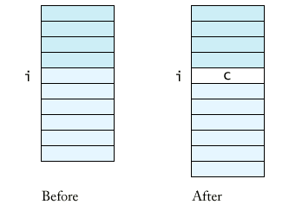
- remove removes an element at an index
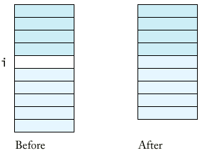

File Purse.java
1 | import java.util.ArrayList;
2
3 | /**
4 | A purse holds a collection of coins.
5 | */
6 | public class Purse
7 | {
8 | /**
9 | Constructs an empty purse.
10 | */
11 | public Purse()
12 | {
13 | coins = new ArrayList();
14 | }
15
16 | /**
17 | Add a coin to the purse.
18 | @param aCoin the coin to add
19 | */
20 | public void add(Coin aCoin)
21 | {
22 | coins.add(aCoin);
23 | }
24
25 | /**
26 | Get the total value of the coins in the purse.
27 | @return the sum of all coin values
28 | */
29 | public double getTotal()
30 | {
31 | double total = 0;
32 | for (int i = 0; i < coins.size(); i++)
33 | {
34 | Coin aCoin = (Coin)coins.get(i);
35 | total = total + aCoin.getValue();
36 | }
37 | return total;
38 | }
39
40 | private ArrayList coins;
41 | }
42

Linear Search Algorithm
public class Purse
{
public boolean find(Coin aCoin)
{
for (int i = 0; i < coins.size(); i++)
{
Coin c =(Coin)coins.get(i);
if (c.equals(aCoin)) return true; //found a match
}
return false; //no match in the entire array list
}
...
}

Counting
public class Purse
{
public int count(Coin aCoin)
{
int matches = 0;
for (int i = 0; i < coins.size(); i++)
{
Coin c =(Coin)coins.get(i);
if (c.equals(aCoin)) matches++; //found a match
}
return matches;
}
...
}

Finding Maximum
public class Purse
{
public Coin getMaximum()
{
Coin max =(Coin)coins.get(0);
for (int i = 1; i <coins.size(); i++) // loop starts at 1
{
Coin c =(Coin)coins.get(i);
if (c.getValue()>max.getValue()) max =c;
}
return max;
}
...
}

File Purse.java
1 | import java.util.ArrayList;
2
3 | /**
4 | A purse holds a collection of coins.
5 | */
6 | public class Purse
7 | {
8 | /**
9 | Constructs an empty purse.
10 | */
11 | public Purse()
12 | {
13 | coins = new ArrayList();
14 | }
15
16 | /**
17 | Add a coin to the purse.
18 | @param aCoin the coin to add
19 | */
20 | public void add(Coin aCoin)
21 | {
22 | coins.add(aCoin);
23 | }
24
25 | /**
26 | Get the total value of the coins in the purse.
27 | @return the sum of all coin values
28 | */
29 | public double getTotal()
30 | {
31 | double total = 0;
32 | for (int i = 0; i < coins.size(); i++)
33 | {
34 | Coin aCoin = (Coin)coins.get(i);
35 | total = total + aCoin.getValue();
36 | }
37 | return total;
38 | }
39
40 | /**
41 | Counts the number of coins in the purse
42 | @return the number of coins
43 | */
44 | public int count()
45 | {
46 | return coins.size();
47 | }
48
49 | /**
50 | Tests if the purse has a coin that matches
51 | a given coin.
52 | @param aCoin the coin to match
53 | @return true if there is a coin equal to aCoin
54 | */
55 | public boolean find(Coin aCoin)
56 | {
57 | for (int i = 0; i < coins.size(); i++)
58 | {
59 | Coin c = (Coin)coins.get(i);
60 | if (c.equals(aCoin)) return true; // found a match
61 | }
62 | return false; // no match in the entire array list
63 | }
64
65 | /**
66 | Counts the number of coins in the purse that match
67 | a given coin.
68 | @param aCoin the coin to match
69 | @return the number of coins equal to aCoin
70 | */
71 | public int count(Coin aCoin)
72 | {
73 | int matches = 0;
74 | for (int i = 0; i < coins.size(); i++)
75 | {
76 | Coin c = (Coin)coins.get(i);
77 | if (c.equals(aCoin)) matches++; // found a match
78 | }
79 | return matches;
80 | }
81
82 | /**
83 | Finds the coin with the largest value.
84 | (Precondition: The purse is not empty)
85 | @return a coin with maximum value in this purse
86 | */
87 | Coin getMaximum()
88 | {
89 | Coin max = (Coin)coins.get(0);
90 | for (int i = 1; i < coins.size(); i++)
91 | {
92 | Coin c = (Coin)coins.get(i);
93 | if (c.getValue() > max.getValue())
94 | max = c;
95 | }
96 | return max;
97 | }
98
99 | private ArrayList coins;
100 | }
101

Storing Numbers in an Array List
- Array lists store objects
- Use wrapper classes to store numbers
- Double wrapper = new Double(29.95);
double unwrapped = wrapper.doubleValue()
- ArrayList data = new ArrayList();
data.add(wrapper);
unwrapped = ((Double).data.get(i)).doubleValue();
- Also have Integer and Boolean wrappers

Arrays
- Construct array:
new double[10]
- Store in variable of type double[]
double[] data = new double[10];
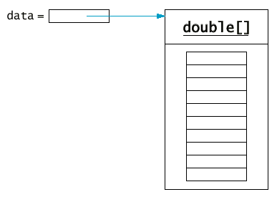
- Arrays have fixed length
- Arrays have element of specific type, not Object
- Use [] to access element:
data[4] = 29.95;
- Get array length as data.length. (Not a method!)

Syntax 13.1: Array Construction
new typename[length]

Example:
new double[10]

Purpose:
To construct an array with a given number of elements.

Syntax 13.2: Array Element Access
arrayReference[index]

Example:
a[4] = 29.95;
double x = a[4];

Purpose:
To access an element in an array

Copying Arrays
- Copying an array reference yields a second reference to the same array
double[] data = new double[10];
// fill array . . .
double[] prices = data;
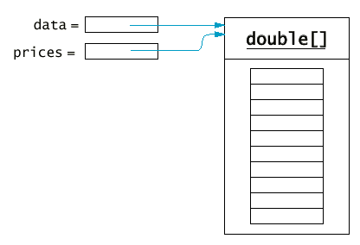
- Use clone to make true copy
double[] prices = (double[])data.clone();
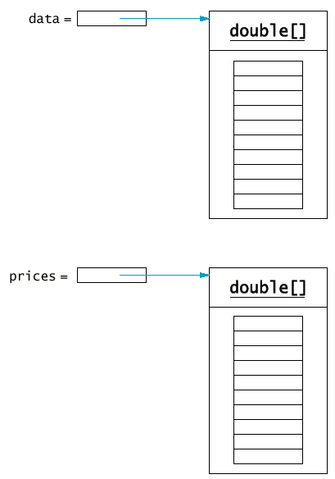

Copying Array Elements
System.arraycopy(from, fromStart, to, toStart, count);
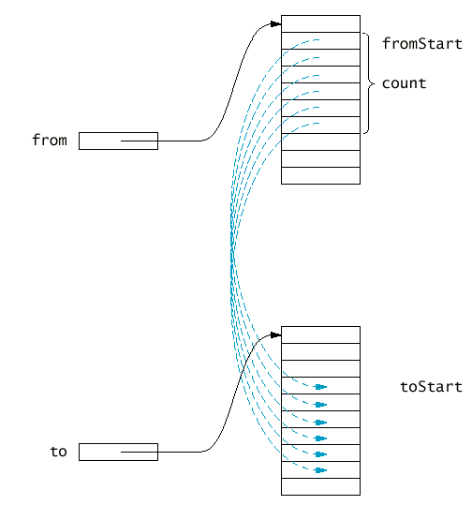

Adding and Removing Array Elements
- Add an element:
System.arraycopy(data, i, data, i + 1, data.length - i - 1);
data[i] = x;
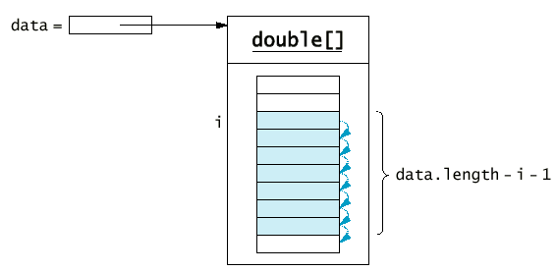
- Remove an element:
System.arraycopy(data, i + 1, data, i, data.length - i - 1);
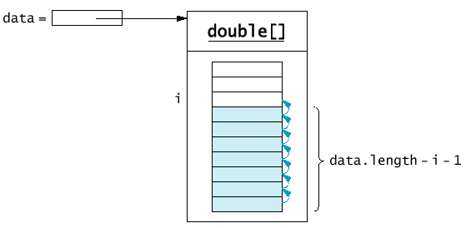

Partially Filled Arrays
- Array length = maximum number of elements in array
- Usually, array is partially filled
- Need companion variable to keep track of current size
- Uniform naming convention:
final int DATA_LENGTH = 100;
double[] data = new double[DATA_LENGTH];
int dataSize = 0;
- Update dataSize as array is filled:
data[dataSize] = x;
dataSize++;

Partially Filled Arrays
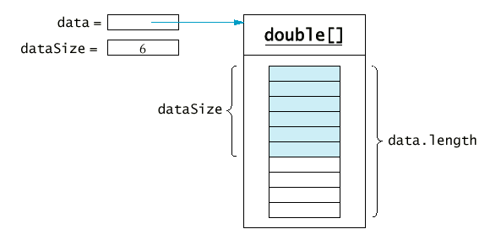

Partially Filled Arrays
- Remember to stop at dataSize when looking at array elements:
for (int i = 0; i < dataSize; i++)
sum = sum + data[i];
- Be careful not to overfill the array
if (dataSize >= data.length)
System.out.println("Sorry--array full");
- Or grow the array:
double newData = new double[2 * data.length];
System.arraycopy(data, 0, newData, 0, data.length);
data = newData;

Growing an Array
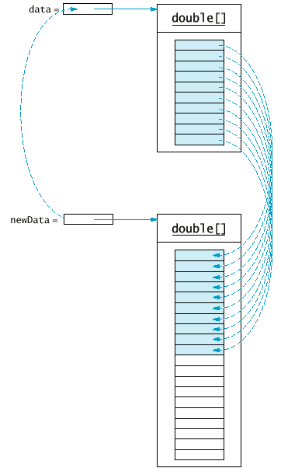

File DataSet.java
1 | /**
2 | This class computes the average of a set of data values.
3 | */
4 | public class DataSet
5 | {
6 | /**
7 | Constructs an empty data set.
8 | */
9 | public DataSet()
10 | {
11 | final int DATA_LENGTH = 100;
12 | data = new double[DATA_LENGTH];
13 | dataSize = 0;
14 | }
15
16 | /**
17 | Adds a data value to the data set
18 | @param x a data value
19 | */
20 | public void add(double x)
21 | {
22 | if (dataSize >= data.length)
23 | {
24 | // make a new array of twice the size
25 | double[] newData = new double[2 * data.length];
26 | // copy over all elements from data to newData
27 | System.arraycopy(data, 0, newData, 0, data.length);
28 | // abandon the old array and store in data
29 | // a reference to the new array
30 | data = newData;
31 | }
32 | data[dataSize] = x;
33 | dataSize++;
34 | }
35
36 | /**
37 | Gets the average of the added data.
38 | @return the average or 0 if no data has been added
39 | */
40 | public double getAverage()
41 | {
42 | if (dataSize == 0) return 0;
43 | double sum = 0;
44 | for (int i = 0; i < dataSize; i++)
45 | sum = sum + data[i];
46 | return sum / dataSize;
47 | }
48
49 | private double[] data;
50 | private int dataSize;
51 | }

File DataSetTest.java
1 | import java.util.Random;
2
3 | /**
4 | This program tests the DataSet class by adding 10,000 numbers
5 | to the data set and computing the average.
6 | */
7 | public class DataSetTest
8 | {
9 | public static void main(String[] args)
10 | {
11 | Random generator = new Random();
12 | DataSet data = new DataSet();
13 | final int COUNT = 10000;
14 | System.out.println("Adding " + COUNT + " random numbers.");
15 | for (int i = 0; i < COUNT; i++)
16 | {
17 | double x = generator.nextDouble();
18 | data.add(x);
19 | }
20 | double average = data.getAverage();
21 | System.out.println("average=" + average);
22 | }
23 | }

Two-Dimensional Arrays
- Matrix with rows and columns
- Example: Tic Tac Toe board
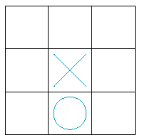
- char[][] board = new char[3][3];
board[i][j] = 'x';

File TicTacToe.java
1 | /**
2 | A 3 x 3 Tic-Tac-Toe board.
3 | */
4 | public class TicTacToe
5 | {
6 | /**
7 | Constructs an empty board.
8 | */
9 | public TicTacToe()
10 | {
11 | board = new char[ROWS][COLUMNS];
12
13 | // fill with spaces
14 | for (int i = 0; i < ROWS; i++)
15 | for (int j = 0; j < COLUMNS; j++)
16 | board[i][j] = ' ';
17 | }
18
19 | /**
20 | Sets a field in the board. The field must be unoccupied.
21 | @param i the row index
22 | @param j the column index
23 | @param player the player ('x' or 'o')
24 | */
25 | public void set(int i, int j, char player)
26 | {
27 | if (board[i][j] != ' ')
28 | throw new IllegalArgumentException("Position occupied");
29 | board[i][j] = player;
30 | }
31
32 | /**
33 | Creates a string representation of the board such as
34 | |x o|
35 | | x |
36 | | o|
37 | @return the string representation
38 | public String toString()
39 | {
40 | String r = "";
41 | for (int i = 0; i < ROWS; i++)
42 | {
43 | r = r + "|";
44 | for (int j = 0; j < COLUMNS; j++)
45 | r = r + board[i][j];
46 | r = r + "|\n";
47 | }
48 | return r;
49 | }
50
51 | private char[][] board;
52 | private static final int ROWS = 3;
53 | private static final int COLUMNS = 3;
54 | }

File TicTacToeTest.java
1 | import javax.swing.JOptionPane;
2
3 | /**
4 | This program tests the TicTacToe class by prompting the
5 | user to set positions on the board and printing out the
6 | result.
7 | */
8 | public class TicTacToeTest
9 | {
10 | public static void main(String[] args)
11 | {
12 | char player = 'x';
13 | TicTacToe game = new TicTacToe();
14 | while (true)
15 | {
16 | System.out.println(game); // calls game.toString()
17 | String input = JOptionPane.showInputDialog(
18 | "Row for " + player + " (Cancel to exit)");
19 | if (input == null) System.exit(0);
20 | int row = Integer.parseInt(input);
21 | input = JOptionPane.showInputDialog(
22 | "Column for " + player);
23 | int column = Integer.parseInt(input);
24 | game.set(row, column, player);
25 | if (player == 'x') player = 'o'; else player = 'x';
26 | }
27 | }
28 | }

